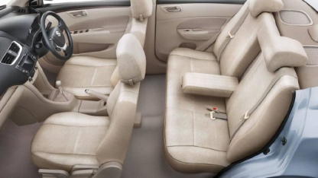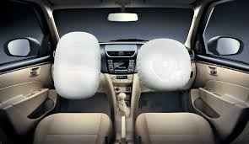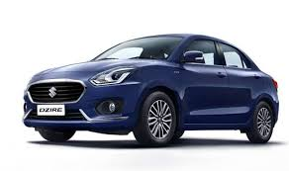

**₹7.06 L**

Contact Showroom at 63639 03997

**Inside color/fabric type  
Power locks, windows  
Air conditioning**

**Odometer mileage  
Transmission type  
Engine size**

**Sound system   
General condition Outside color**

USB+AUX IN

Made in Office 2007 for office2007.com

Tilt Steering Low Fuel Warnig

Fuel Consumption Display

**Keyless entry and Security alarm**

**Chrome inside Door Handle**

Click here to enter text.

**Seat Belt Reminder**

Click here to enter text.

Front Fog Lamp

**Power Steering**

Foldable Grip Assistant

**Lane Change Indicator**

(555) 555-0125